E();



# Reynoldsburg Lodge #340

**7350 Broadwyn Drive**

**Reynoldsburg, Ohio 43068**

**(614) 866-8179**

[**http://www.mason340.com**](http://www.mason340.com)

|  |  |
| --- | --- |
| **Stated Meetings:** | **1st and 3rd Tuesdays @ 7:30 PM** |
| **Special Meetings:** | **As called by WM** |

# Lodge Officers

|  |  |
| --- | --- |
| **Worshipful Master** | Derek Martin |
| [wm@mason340.com](mailto:wm@mason340.com) | 614-747-5150 |
|  | |
| **Senior Warden** | Alex Jackson |
| [sw@mason340.com](mailto:sw@mason340.com) | 614-371-1424 |
|  | |
| **Junior Warden** | John Wronski, PM |
| [jw@mason340.com](mailto:jw@mason340.com) | 614-861-3883 |
|  | |
| **Secretary** | Gary Wehr, PM |
| secy@mason340.com | 614-202-1523 |
|  | |
| **Treasurer** | Buck Boyd |
| treas@mason340.com | 614-759-4398 |
|  | |
| **LEO** | Charles Ashley |
| [leo@mason340.com](mailto:leo@mason340.com) | 614-861-3425 |
|  | |
| **Trestleboard Editor** | Jack Freund |
| tb@mason340.com | 614-577-1062 |
|  | |
| **Web Editor** | Ken Cohen |
| Ken.Cohen@mason340.com | 614-577-0017 |

**Next Trestleboard Deadline**: 10 October 2014

***Mark Your Calendars!***

# Masonic Calendar

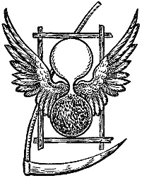

Growing old is no more than a bad habit which a busy man has no time to form. -Ande Maurois

|  |  |  |
| --- | --- | --- |
| **September** | | |
| 2 Sept | 340 Stated Meeting | 7:30P  6:30P – Dinner |
| 6 Sept | Lodge Golf Outing | 8A |
| 16 Sept | 340 Stated Meeting | 7:30P  6:30P – Dinner |
| 20 Sept | Funnel Cake sale at Reynoldsburg Soccer Tournament |  |
| 25 Sept | 14th District Quarterly Meeting @ Reynoldsburg Lodge |  |
| 27 Sept | 340 Lodge Breakfast | 8-11A |
|  | | |
| **October** | | |
| 7 Oct | 340 Stated Meeting | 7:30P  6:30P – Dinner |
| 17-18 Oct | Grand Lodge in Cincinnati |  |
| 21 Oct | 340 Stated Meeting | 7:30P  6:30P – Dinner |
| 22 Oct | DDGM Installation | TBA |
| 25 Oct | 340 Lodge Breakfast | 8-11A |
| 29 Oct | DDGM Installation | TBA |
| 30 Oct | DEO Installation | TBA |
| **November**   |  |  |  | | --- | --- | --- | | 4 Nov | 340’s Annual Meeting with Election of Officers | 7:30P  6:30P – Dinner | | 9 Nov | DEO Installation | TBA | | 11 Nov | Veteran’s Day |  | | 18 Nov | 340 Stated Meeting | 7:30P  6:30P – Dinner | | 27 Nov | Thanksgiving |  | | 29 Nov | 340 Lodge Breakfast | 8-11A | | | |

# From the East Derek Martin, WM

I hope everyone had a great summer!

Reynoldsburg lodge is now coming back to light after a brief summer break. I want to take the opportunity to call out to those members that have a little extra time that they would like to donate to the lodge.

As most of you may know, last year the lodge bought a deep fryer to make funnel cakes. This was a part of our plan to raise funds for the lodge. This summer the lodge participated in the tomato festival and the sweet corn festival. I want to say a big thank you to everyone that volunteered. It was no small undertaking and was a learning opportunity on how to run the system and get our flow but everything seemed to go well. Our plan for the future is to have a pool of 30 people that we can call on to run our trailer. Please, if you can, let an officer know that you would like to be on the list of volunteers. My hope is that we will continue to be in these festivals and many more so that we may start to turn the finances of the lodge around. Again, if you can spare even a little time, please see an officer.

I’m looking forward to the remaining five meetings where I will have the pleasure of serving as Master. We have a lot that still needs to be done: degrees, business, and of course, some fun. I hope to see everyone there and remember the annual meeting is November 4th. Please come out and support your new officers.



# P:\Photos\Lodge\2014 Installation\Blk Wht Officers\Alex - TB.jpgFrom the West Alex Jackson, SW

Dust off those working tools and unfurl those aprons! The summer months have passed and our Lodge is bustling with activity once again. By the time you read this, we will be reporting on fundraisers that will have passed (and hopefully been highly profitable), catechisms returned (hopefully flawless), and officers returning to their stations (hopefully wiser than before we went dark). None of this would have been possible without each brother who has come before. The foundation of this institution has been laid and revisited often but we must trust that our forefathers placed the first stone squarely and now we must continue to build Freemasonry up.

Often as Masons we hear and recite the words “Making Good Men Better” but what exactly are we doing to make them better? What does this phrase mean to each of us so that we might impart our truths on the next generation? How might we implement these ideas and grow as a brotherhood of “great men”?

I wish I had these answers to simply dole out to each of you but honestly I think that would be shunning, if only slightly, that pursuit of enlightenment, which we have all chosen to undertake. I have been made better by the interactions I make every single time I see a brother Mason. I learn something new from that man that I take with me on my journey through life that I hope to apply in a meaningful way. I’m made better each time I see my ring or notice a beehive and I’m instantly reminded that I am a shining beacon, representing our Lodge and Masonry itself and that I should do no less than set the example for those around me to be better.

Is that, alone, enough to use our key tagline? NO. I think there is so much more that I, and others, could be doing to fulfill that promise that we’re making each time we speak the words. Many programs are going into place to see that we do just that, MORE even. Not I, nor any one of us can do this alone, but each and every one of us can be the difference we want to see in the world and I challenge you to do just that.

Another year is coming to a close and so many memories have been made, but for many that is just the beginning. Please help make these memories just the first stepping stones for many generations to come and get involved with the obligations you took. I look forward to meeting each of you squarely and on the level and being made better for the occasion.

# K:\DCIM\100CANON\John - TB.jpgFrom the South John Wronski, PM

Back in 1958, Sean Connery starred in a movie called *Another Time, Another Place*. This title makes a useful segue to talk about some Masonic schedule changes over the next twelve months.

Let's begin with “another time.” The annual inspection, which is in the Master Mason Degree, is set for 16 June 2015. That will be the last stated meeting until September 2015. It is also an opportunity for more brethren to participate than in the past. Just think – no snow. How about that, snowbirds! - For students and teachers – no school, no bitter cold, no icy roads, no darkness before the meeting ends. As a bonus, the Grand Master plans to perform in the ritual. Mark your calendars now.

Let's move on to another place. Most of Reynoldsburg Lodge's activities take place in the temple, no surprises there. Last summer, the lodge sponsored a funnel cake stand at a local soccer tournament. This year, the stand has become a trailer, which will appear at the tournament again, as well as the Tomato and Sweet Corn Festivals. While these events will probably have ended by the time this article is published, you can expect similar or greater opportunities to get out and about next Summer. Incidentally, the funnel cake sales have become the lodge's main source of income outside of dues, so please come around to eat or work.

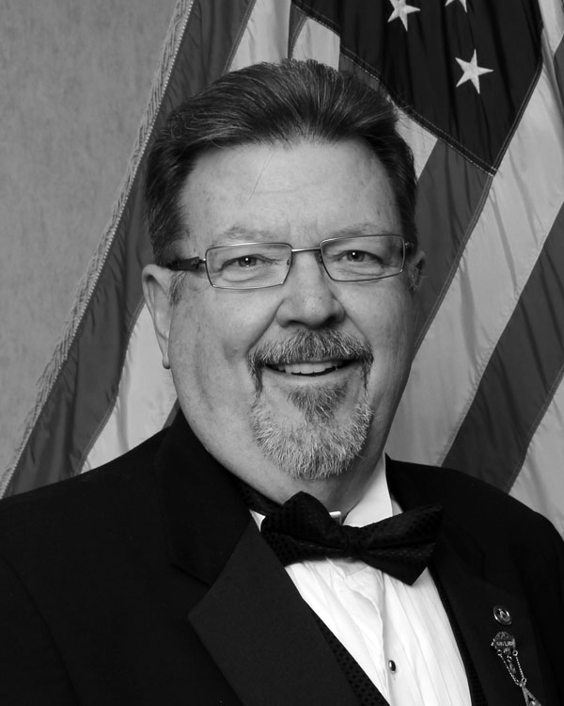From the Secretary  
Gary Wehr, PM  
  
“What I did on my summer vacation”

Last year I wrote an article about spending the month of June in Florida and how I wished I had contacted some of our Lodge members that now reside there. Well this year I thought things out prior to going on vacation. I had contacted seven members that live relatively close to where I was visiting for the week. After all was said and done, I did get to meet up with three of them. The others were on vacation themselves at that time so we weren’t able to get together, but there’s always next year.

Our first stop (my wife Sandy was with me too), was in Palm Coast where we connected with Bro. Brian Van Horne. He was in-between deliveries for his job so we met at a local McDonalds. We spent around 30 minutes talking before he needed to get back to work. I gave him his 25-year pin, a Lodge lapel pin from our 150th anniversary and an advance copy of the last Trestleboard. What made me feel even better about this side trip was that a week later Bro. Van Horne called me at home to thank me again for taking the time to pay him a visit.

A few days later, we traveled to the other side of the state to visit some more members. This time, my brother Keith and his wife, Diane accompanied us. We drove over to Spring Hills (just on the North side of Tampa). There we spent some time with two members. The interesting thing is that they only live two houses apart and did not know each other when they moved in. Actually, Bro. Leon Walker already lived there and Bro. John Pinkerton moved in later. According to Bro. Pinkerton, Bro. Walker and his wife were extremely helpful with his moving into the area. Imagine, moving to another state and actually end up two doors away from a fellow Lodge member! We had a great time talking with John, Leon, and his wife. Leon made references to WB Ray Belfrage and his wife Dottie and WB George Godfrey. Bro. Walker will receive his 60-Year pin this coming year. Each year the Grand Master goes to Florida and holds a couple of events for the relocated Ohio Brethren. If the Grand Master cannot present it to him on his trip to Florida then I will seek permission to do it when I return next July. We all had a good time together. I also presented Leon and John with the Lodge lapel pin and Trestleboard. I look forward to re-connecting with these and other members of our Lodge next year. If you would like to do something like this, just let me know where you’re traveling and I’ll see if there’s a member along the way. You too can present them a pin and spend some valuable time making a Lodge member feel like they are not forgotten.  
 *Editor’s note: pictures from this trip are in the Lodge Photos section of this Trestleboard*

# **K:\DCIM\100CANON\Buck - TB_edited-1.jpg**From the Treasurer Bro. Buck Boyd

Some good news! Our application to the state of Ohio for Real Property Tax Exemption has been approved. The final determination came on June 27th of this year. This means we will not have to pay property taxes next year and in the future.

This news comes at a time when the lodge is struggling to find ways to make money, enable it to move ahead, and stay solvent. Each year we try to find new ways for raising funds. Spaghetti dinners have run their course and no longer attract the public the way they once did. We have tried dinners, games, and rummage sales, but nothing brings in the type of money needed to run the lodge and plan for unforeseen expenses.

Our monthly breakfast does a great job raising money for our Special Olympics charity, but, even when we have an exceptional turnout, after making the charity donation there is minimal profit for the good of the lodge. However, the breakfast is great exposure for the lodge and many new members have joined after partaking in a good meal.

This brings me to our latest efforts in fund raising – participating in festivals! So far, we have been accepted into three festivals this summer and fall. Hopefully, we will add one more before the festival season winds down. The first was the Reynoldsburg Tomato Festival on 15-16 August. At this event, we sold funnel cakes using the funnel cake fryer we previously purchased for this purpose and which we expect to be our main fundraiser item in the future.

The next festival will be the Millersport Sweet Corn Festival coming up on 27-30 August. We will not be able to sell our funnel cakes for this event because of contracts with other vendors who sell these and have been with the festival for many years. The number of vendors selling any one item is limited to ensure each vendor is able to realize a good profit. Instead, it was decided (and approved to) sell pulled pork sandwiches, sloppy joes, and jumbo hot dogs, which include a drink and a bag of chips.

The third commitment is the Reynoldsburg Youth Soccer Tournament, 21-22 September, where we will offer our funnel cakes.

We are in great need of volunteers to help work the many shifts during these events. With enough helpers, we can keep each shift to just a few hours. However, that depends on how many of you can commit to helping. If your spouse or children over 16 years of age would like to assist, we will gladly accept all the help we can get.

Please call any officer and he will take down the date and time you are available to work. Or call, me, Buck Boyd, to discuss date/time availability; I will be happy to work with you in finding a slot that suits your needs. My number is 614-759-4398. If I do not answer, please leave your name and number and I will call you back promptly.

*Editor’s note: Bro. Boyd talks more about the new Lodge Trailer later in this issue of the Trestleboard and shares some pictures.*

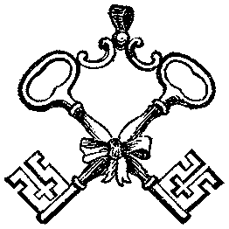

# C:\Users\HPLaptop\AppData\Local\Microsoft\Windows\Temporary Internet Files\Content.IE5\J3BN0N4Z\MC900437565[1].wmf

# Reynoldsburg Lodge Photos

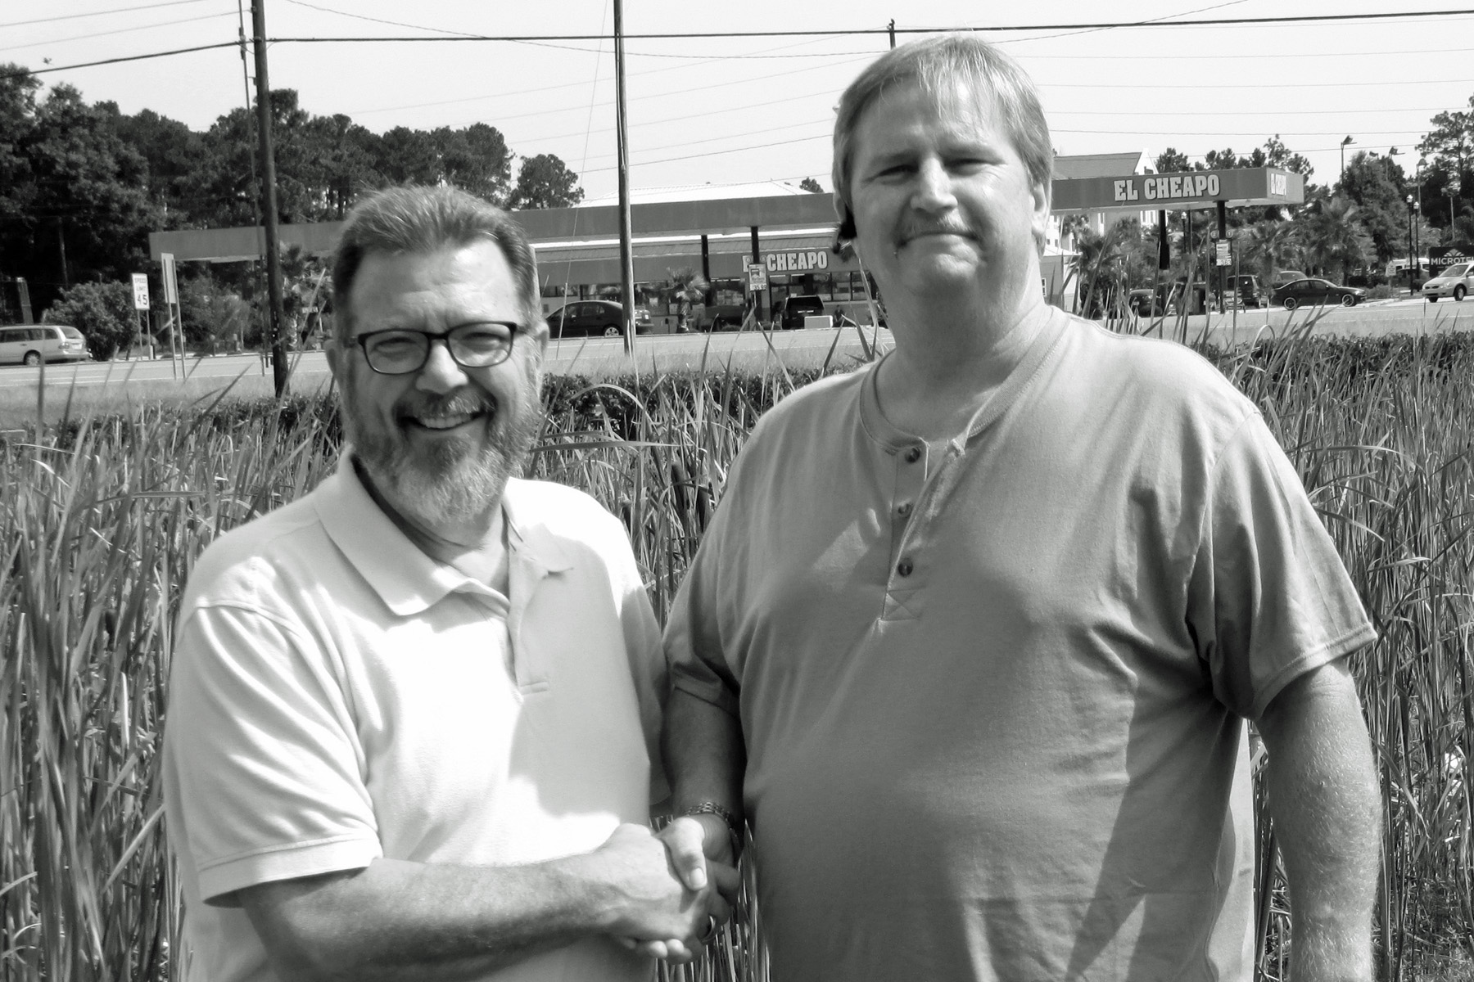

Secretary Gary Wehr, PM, meets with Brothers while on vacation in Florida. Here he is shaking hands with 25-year member Bro. Brian Van Horne.

Below he meets with soon-to-be 60-Year member Bro. Leon Walker (center) as well as Bro. John Pinkerton (right).

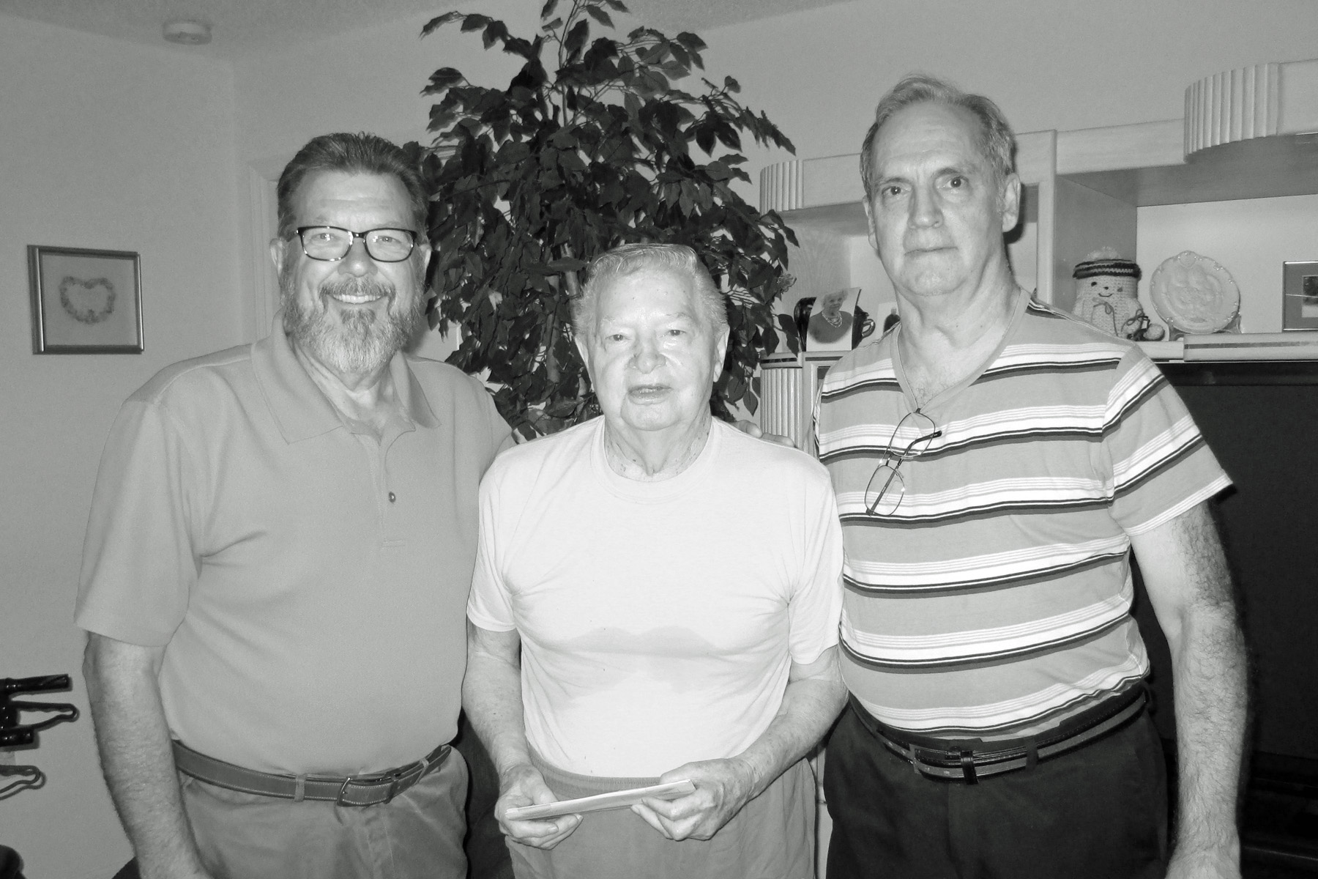



Ken Cohen, PM, DEO with some of the Reynoldsburg’s Special Olympics participates

Rent the Lodge  
Got a big family gathering? Office party?  
Rent Godfrey Hall for your function  
Just $50 to rent Godfrey Hall   
for members of   
Reynoldsburg Lodge, Whitehall Lodge, or Eugenie Chapter  
Only $75 for non-members  
Additional Charge for kitchen use  
Contact WM Derek Martin   
at 614-747-5150 for details

From the Secretary and YOUR Lodge;

It is getting to be that time of year again: your Annual Dues are due in a couple of months (on 4 Nov). We want to give you ample time to pay them in a timely manner. Pay early and avoid the holiday rush on your wallet! Please make out just one check. If you select the “misc charities,” the Lodge will select the appropriate one depending on the greatest need after all the dues payments are collected.

Please tear out this page and submit it with your payment.

|  |  |
| --- | --- |
| Lodge Dues | $65.00 |
| Lodge’s General Operation Fund | $ |
| Lodge Misc. Charities | $ |
| Grand Lodge Misc. Charities | $ |
| Ohio Masonic Home | $ |
| Specific Charity/Fund of Your Choosing | $ |
| **Total Amount enclosed** | **$** |

|  |  |
| --- | --- |
| Name |  |

**YOUR ANNUAL DUES ARE TO BE SUBMITTED TO THE SECRETARY BY 4 NOV 2014**

Please make your check payable to *Reynoldsburg Lodge #340*, and mail it to:

Reynoldsburg Lodge #340

℅ Gary Wehr

7933 Brookfield Pl

Canal Winchester, OH 43110

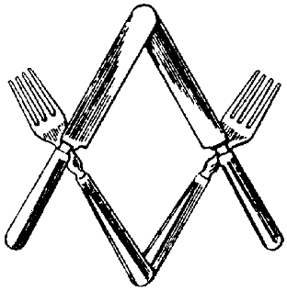

**Don’t forget our monthly breakfast on the last  
Saturday of EVERY month, 8-11am. All you can eat for $6.**

# Meet the New Reynoldsburg Lodge # 340 Funnel Cake Trailer!!

If you have heard about our new trailer for fund raising and are wondering what it looks like, well check it out! These pictures should fill you in.

The trailer was purchased without the use of lodge funds. Instead, the money was raised through the sale of Masonic items in our Pride Case (such as handsome ties, sharp hats, and smart-looking pins), a small amount from our Wish List account, and a generous donation from a Brother, allowed us to purchase a used trailer from a local V.F.W. lodge.

After a few repairs, and lots of elbow grease, we now have a vehicle that can be used at many events for fund raising in the future.

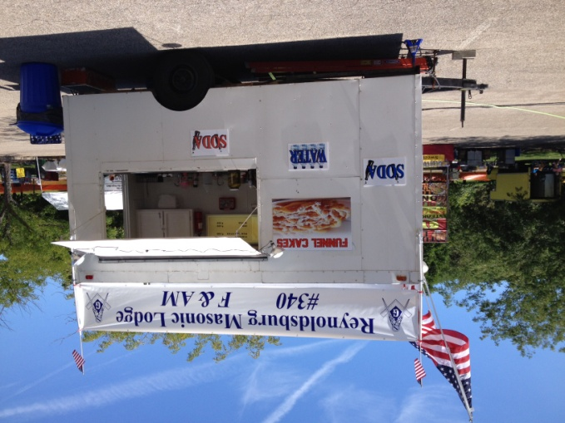

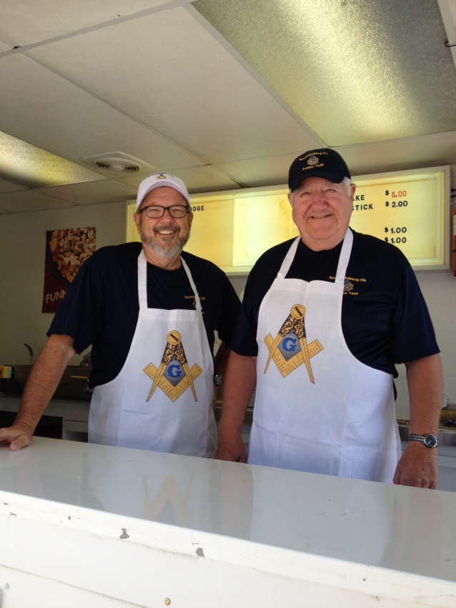

Gary Wehr, PM ,Secretary and Bob Stacoffe, PM ready for business!

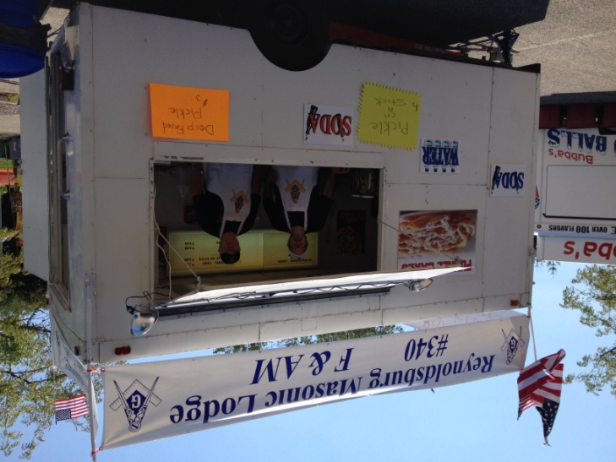

Open for Business at the Reynoldsburg Tomato festival.

# Felix Sit Natalis Dies



## July

|  |  |
| --- | --- |
| 3 | Charles Houdashelt |
| 3 | Michael Tempio |
| 8 | Thomas Maziar |
| 14 | Malcolm Talbot, PM |
| 14 | Phillip Eichhorn |
| 16 | David Quinn |
| 16 | Matthew Spain |
| 17 | Richard Biggs |
| 17 | Ronald Lautzenheiser |
| 18 | Robert Toledo |
| 21 | James Vaigl |
| 22 | Derry Johnson |
| 23 | Bill Bickel |
| 23 | Kenneth Pollock |
| 24 | Leon Walker |
| 24 | Anthony Torchia |
| 26 | Larry Johnson |
| 27 | Timothy Wertman |
| 28 | Edward Patsch |
| 29 | James Farley |

## August

|  |  |
| --- | --- |
| 1 | Jason Johnson |
| 2 | Bill Lollar |
| 5 | Mitchell Buchanan |
| 12 | Perry Walz |
| 12 | Sami Faour |
| 13 | Bob Stacoffe, PM |
| 14 | Milton Keaton |
| 15 | George Stribick |
| 15 | Mike Wehr |
| 17 | Greg Leitch |
| 18 | David Sigman |
| 19 | Christopher Baer |
| 21 | Ross Hite |
| 22 | Thomas Jones |
| 23 | David Bertschi |
| 24 | Albert Bliss |
| 24 | Ryland Kemmerling |
| 24 | Mark Ulloa |
| 25 | Charles Lepley |
| 25 | Michael Arnold |
| 26 | Kenneth Luckay |
| 30 | Scott Thomas, PM |
| 30 | Todd Dunn |
| 31 | Jordan Myers |

**Gaudeamus Igitur!**

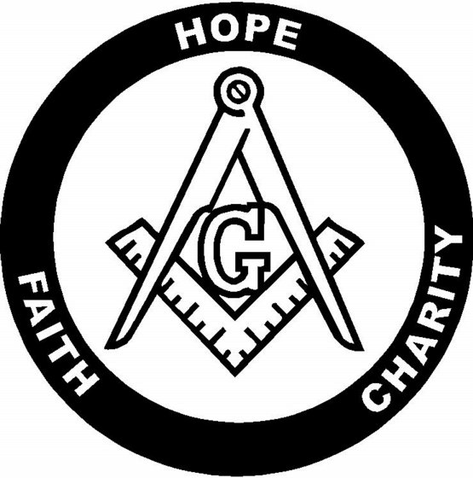

|  |
| --- |
| Reynoldsburg |
| Masonic Lodge |
| Golf Scramble |
| Trustee's Event |
| Saturday September 6, 2014 |
| At Broadview Golf Course |
| Tee times start at 8:00AM |
| Anyone interested in playing please contact |
| Rod Basye at |
| 614-325-5689 text, call or email |
| Rodrat1976@msn.com |
| Open to all golfers |
| $40.00 per person |
| Proceeds will benefit Reynoldsburg Helping Hands |
| After golf, we'll come back to the lodge, have lunch and see who has bragging rights till next year |

# C:\Users\HPLaptop\AppData\Local\Microsoft\Windows\Temporary Internet Files\Content.IE5\QU7R0NSU\MC900390726[1].wmf

# Please support OUR SPONSORS

# Ace Hardware-1.jpg

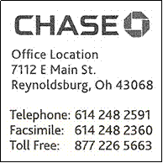Please support OUR SPONSORS

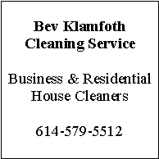



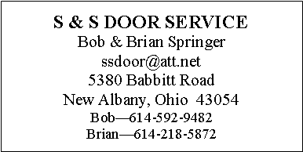

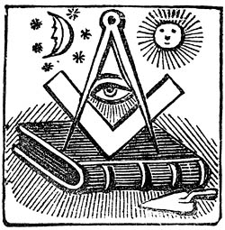

P.O. Box 624

Reynoldsburg Lodge #340 F&AM

Reynoldsburg, OH 43068

DATED MATERIAL – PLEASE DO NOT DELAY

NON-PROFIT ORGANIZATION  
U.S. POSTAGE PAID  
PERMIT NO. 30  
REYNOLDSBURG, OHIO 43068